**Lab Assignment#1:Playing with Amazon Elastic Compute Cloud(EC2)**

Student Details : Mugdha Wadikar, 013768534

**Objectives**: This lab assignment is designed to enable students to gain some hands-on experience on Amazon’s EC2. Each student is required to work on this laboratory assignment individually and submit your deliverables into Canvas.

The basic requirements are given below:

* Set up a user account in your selected cloud technology online.
* Login to the select cloud and make necessary configurations for your selected application program.
* Launch and deploy your selected application (or an instance) onto your selected cloud environment.
* Use Please also use Amazon’s CloudWatch to monitor and present your application performance and resource usage. (Hint: https://aws.amazon.com/cloudwatch/) Note: you must be specific on your selected application. (Please make sure that each member selects different application). Submission: When you turn in your report, you need to watch out the Turnitin indicator’s your Canvas. Your required deliverables:
* Submit your recorded operation scenario (as a screen-recording file) on your laptop from (a) and submit to your Canvas. In case, your file is too big, you can set up in an external Drop Box, and provide the link here.
* Submit your procedure and specification in your Canvas account, including your Amazon’s CloudWatch feature and report.

**References**: AWS introduction: https://aws.amazon.com/getting-started/ EC2 Introduction and Tutorial: https://aws.amazon.com/ec2/getting-started/

**Detailed Steps**:

**1. Set up a user account in AWS:**

Create an AWS account through http://aws.amazon.com/ and enter login credential information. I already had an account, so I have logged in.

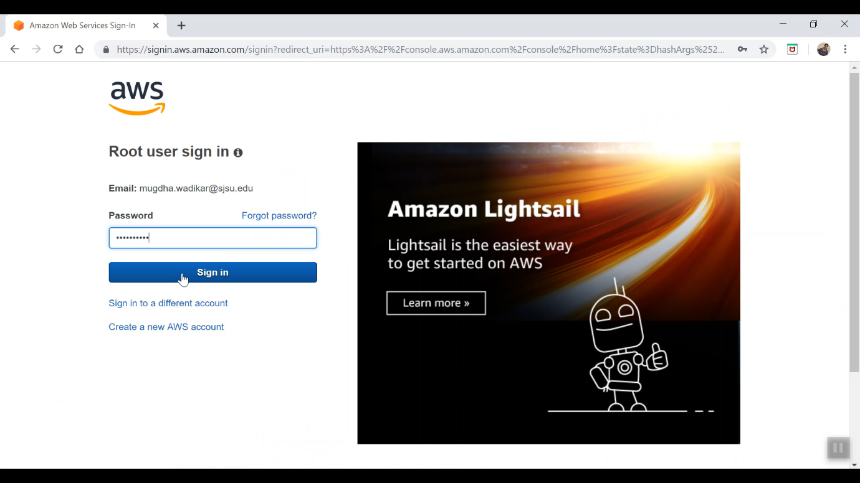

**2. Create an EC2 instance:**

1. Log in to the AWS Management Console. Next, click the “Amazon EC2” tab.

https://us-west-1.console.aws.amazon.com/console/home?region=us-west-1#

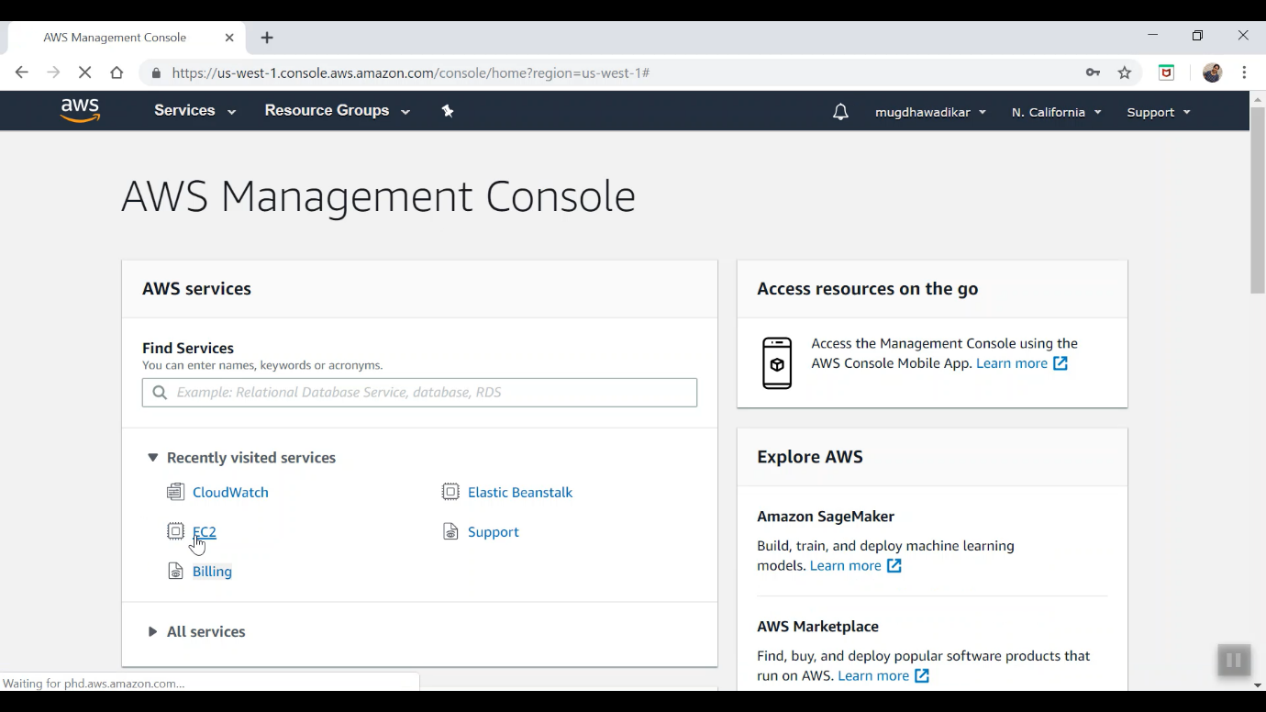

1. Click “Launch Instance”.

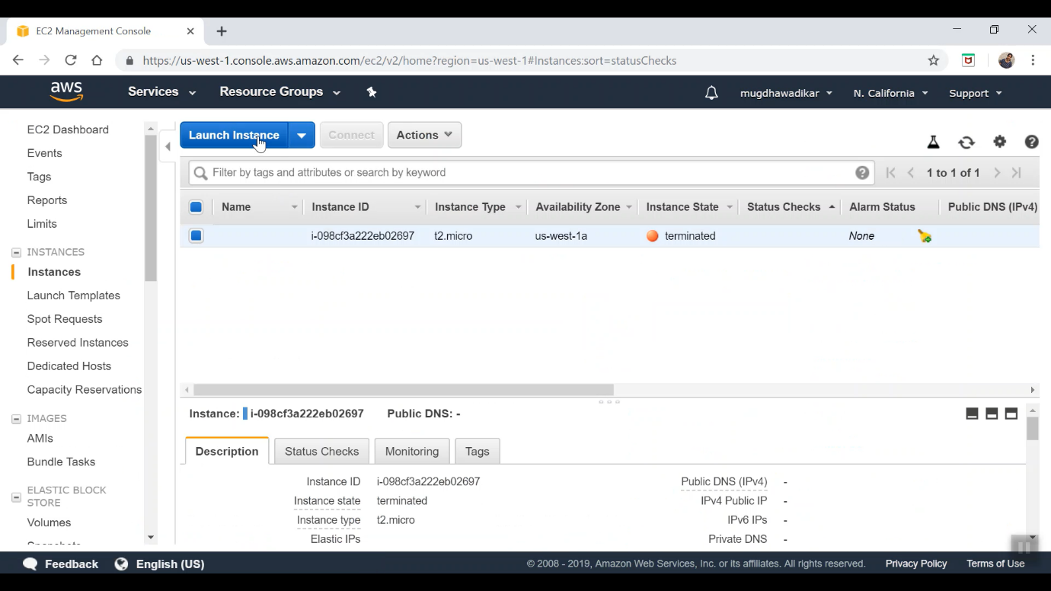

1. Create an instance based on your need. In this case, I created a free Amazon Linux AMI 2018 64-bit (x86) instance.

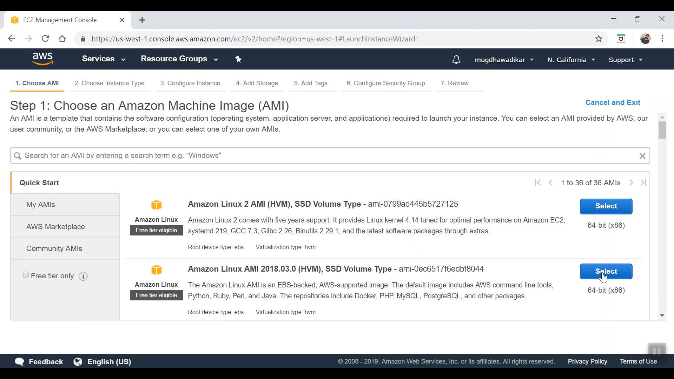

1. Select the instance type of your choice. In my case I selected the GENERAL PURPOSE. T2 micro instance type which is for free and then click review and launch.

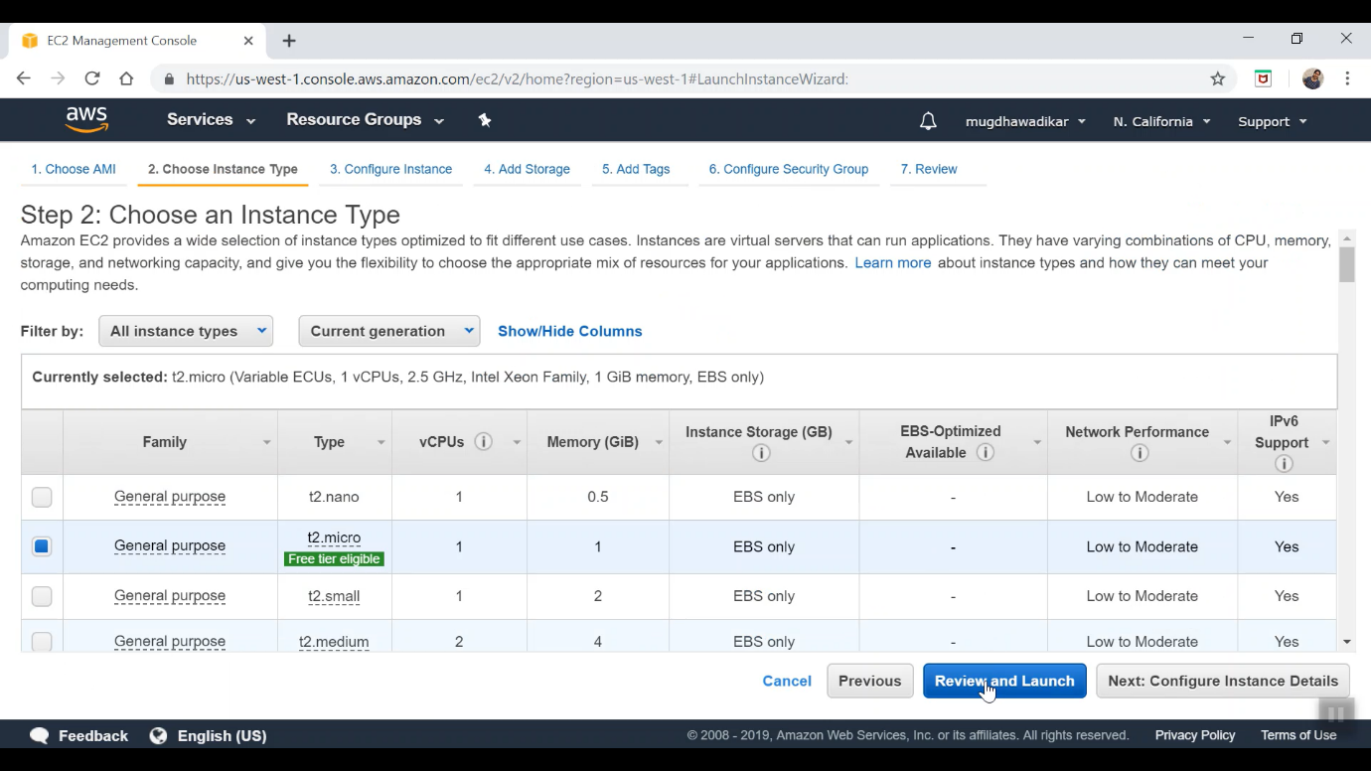

1. Configure Security Group : Create a new Security group. Write the Security group name and description.

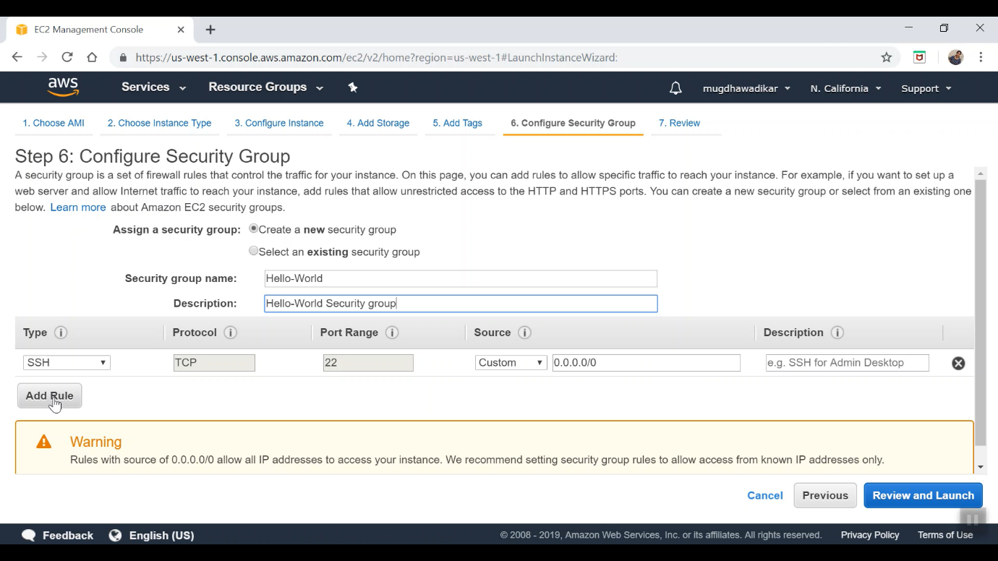

1. I wanted some ports such as http, https, 9000, etc to be accessible for hosting the web application. So, add rules and under each rule select different types: SSH, HTTP, HTTPS, Custom TCP and select source as ”Anywhere”. Launch the instance.

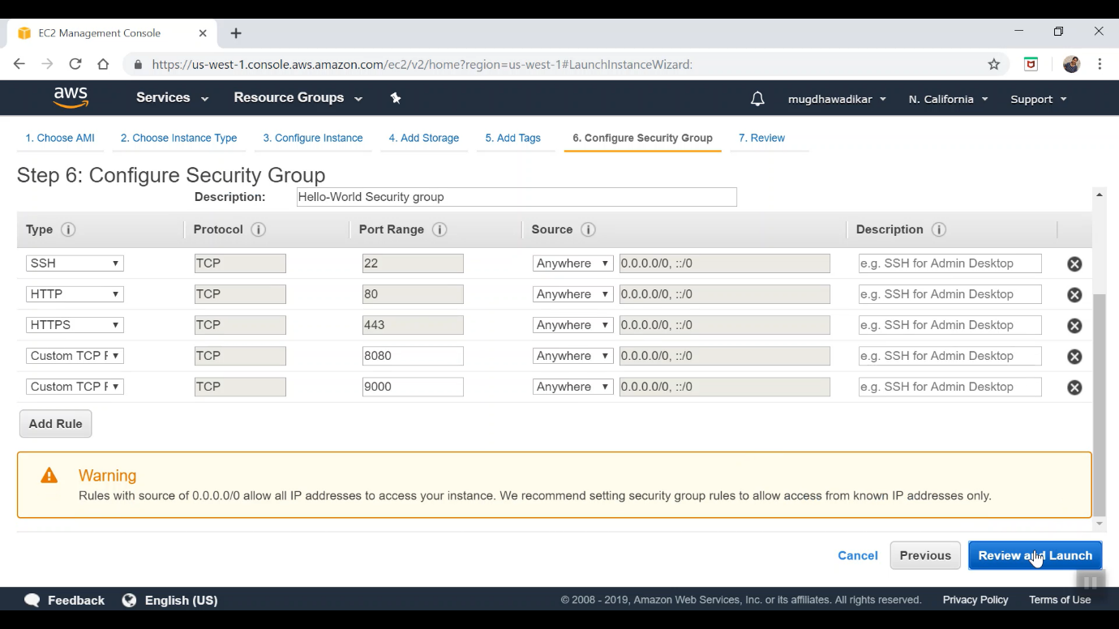

1. Now you will see a message to create a new key pair or use existing. Since we are using first time create a new public – private key pair and give it a name. After this click download key pair and once the key is downloaded click Launch Instance.

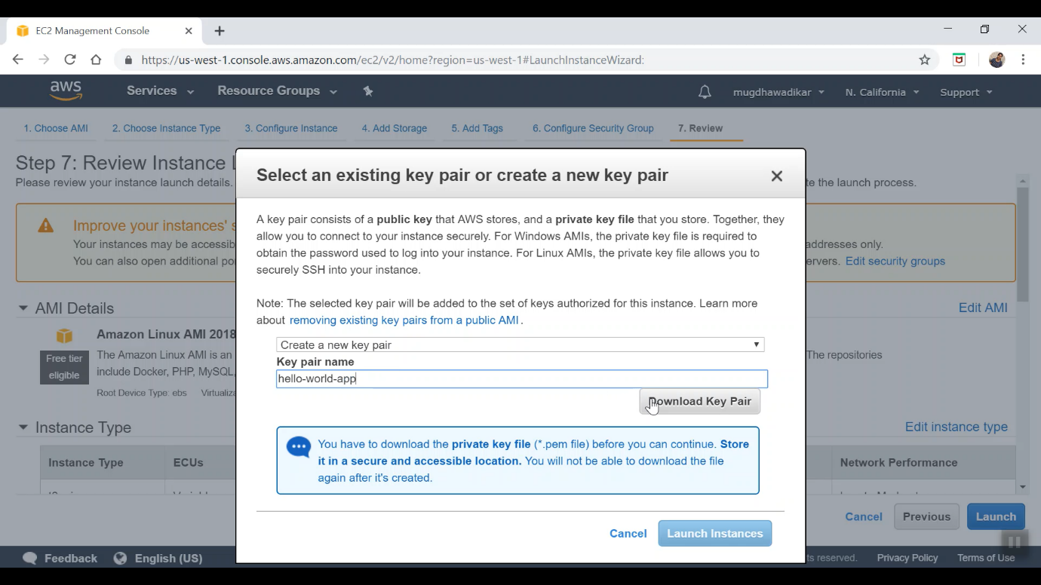

1. After this a screen appears which says Launching instance. If you see the following page, a new instance is launched successfully.

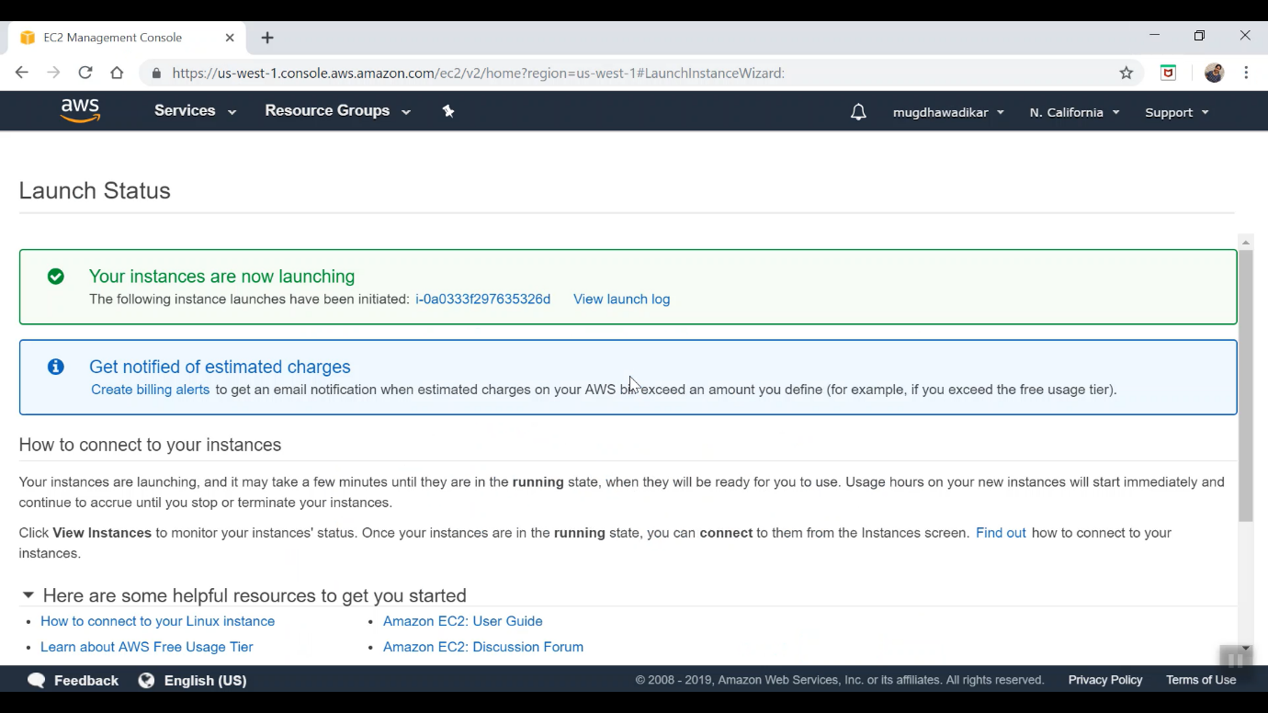

1. Now click on view instance to see your instance status. You can see your just created instance is in running status through the following web.

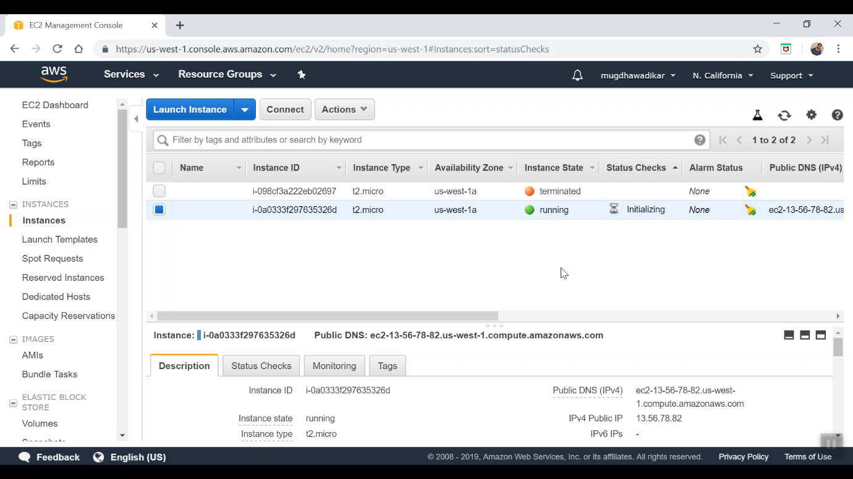

**3. Managing the EC2 instance and running a sample programme:**

1. Connect instance through ssh client.

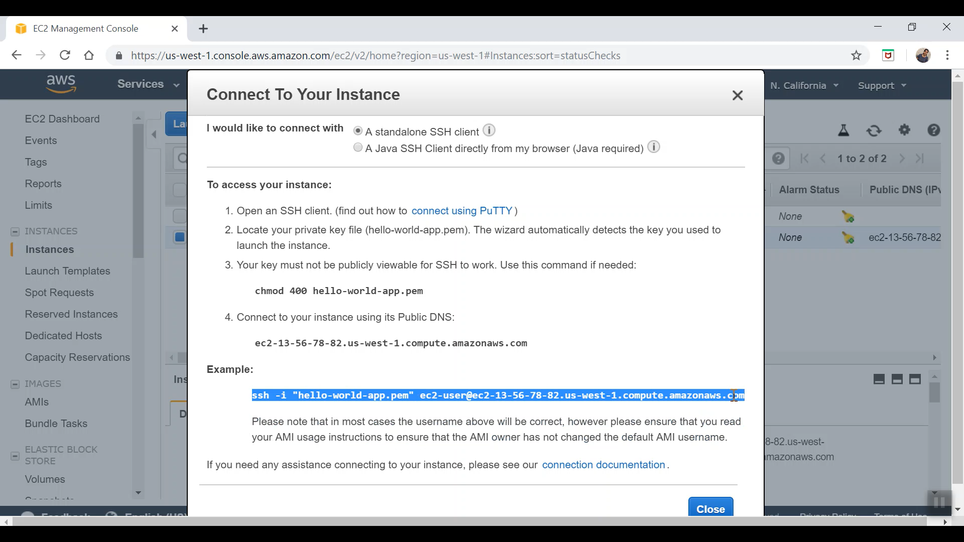

1. I am using Git Bash at the location where we have saved the pem file to connect ssh client.

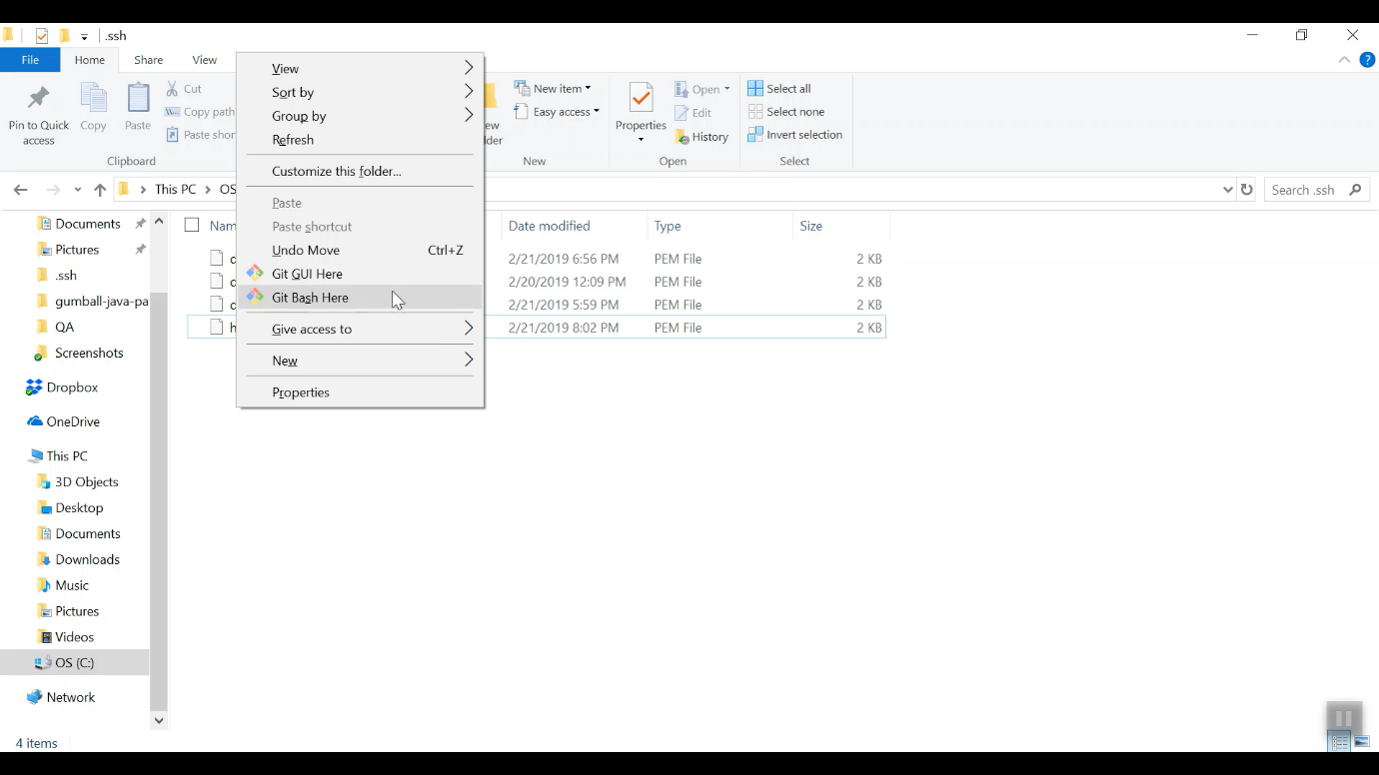

1. Connect to instance through the following commands:

ssh -i “file_name.pem” ec2instance-compute.amazon.com

And type yes if asked for user prompt.

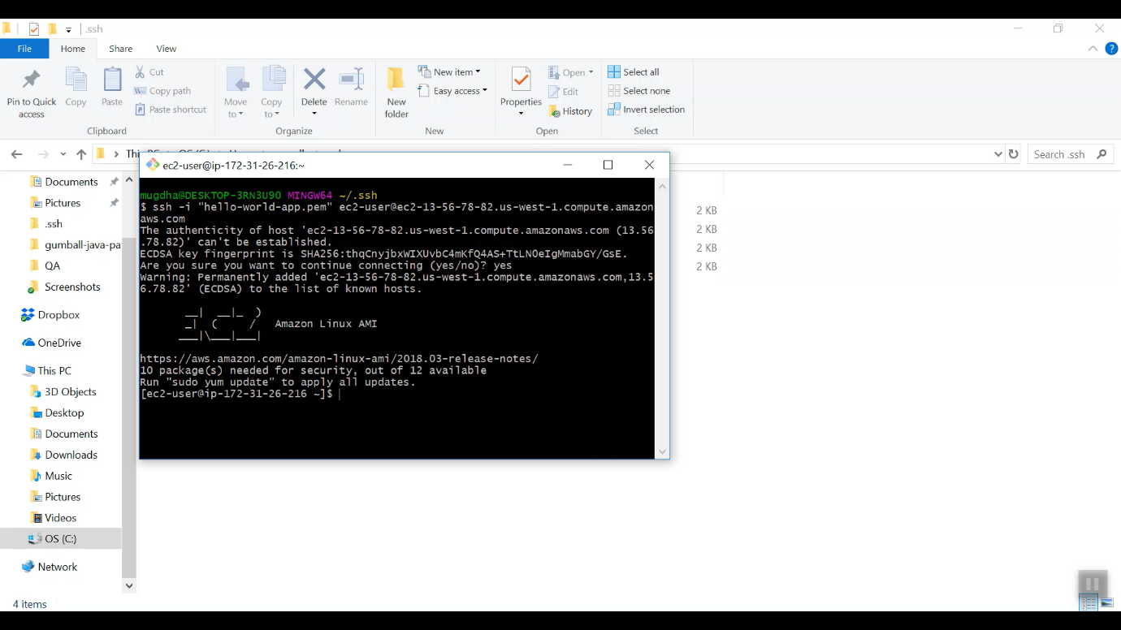

1. Install node.js Through following instructions:
2. sudo dnf install -y gcc-c++ make

curl -sL https://rpm.nodesource.com/setup_8.x | sudo -E bash –

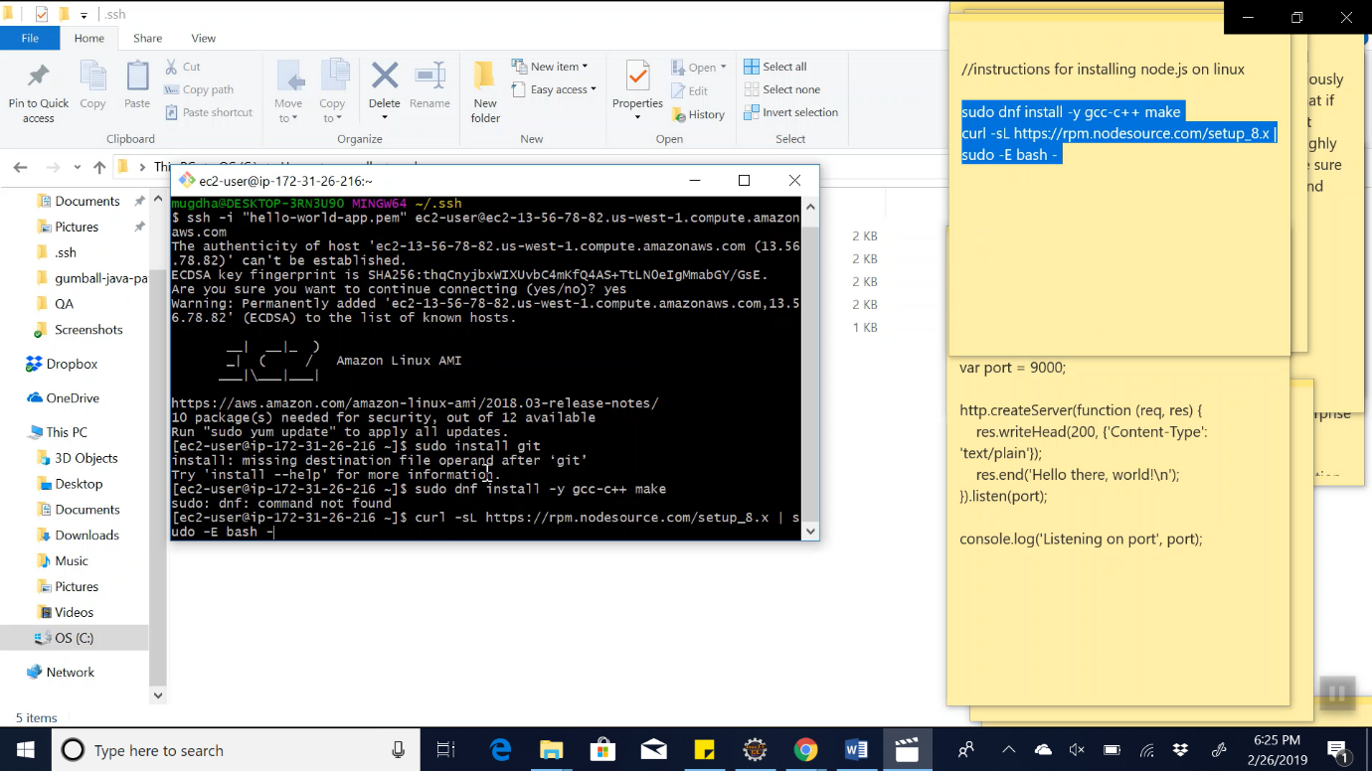

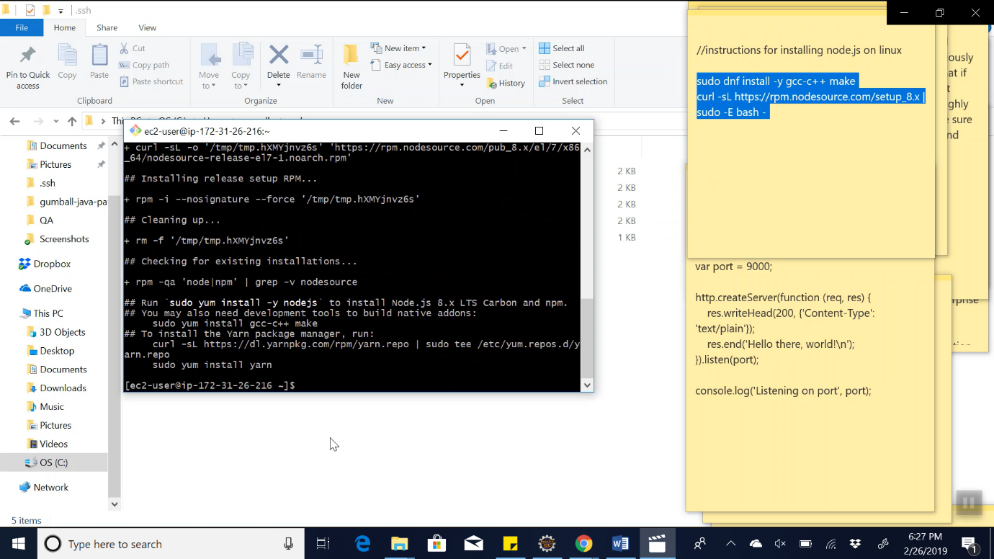

1. sudo yum install -y nodejs

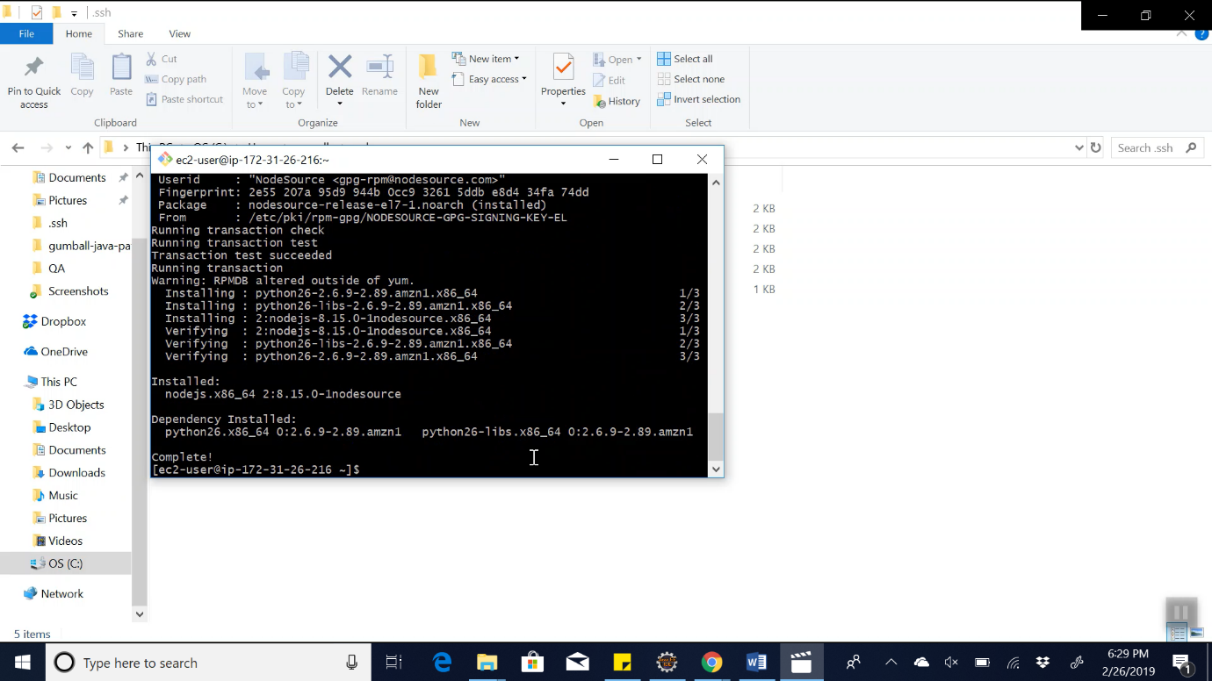

1. Create a new directory in the folder and create app.js file

mkdir demo

vim app.js

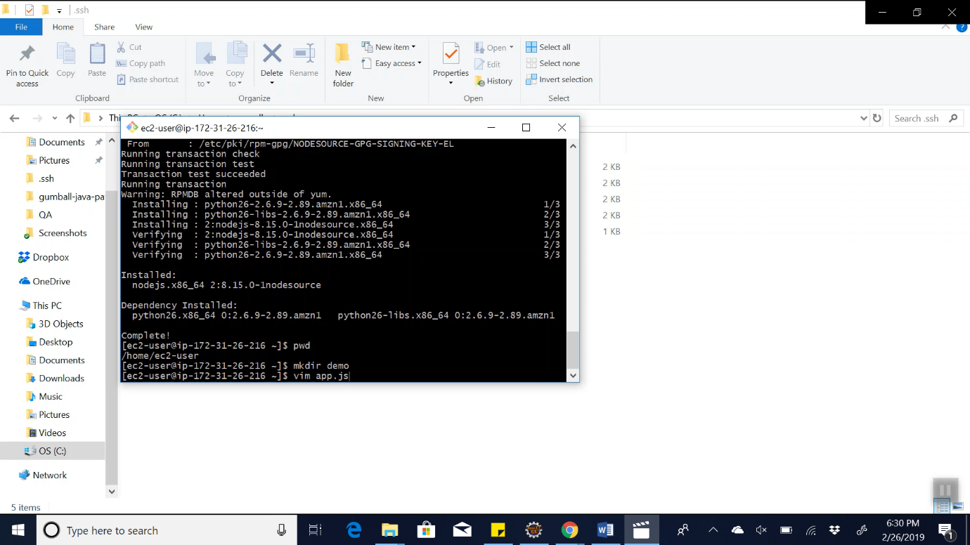

1. Copy the sample nodeJs program written on notepad:

var http = require('http');

var port = 9000;

http.createServer(function (req, res) {

res.writeHead(200, {'Content-Type': 'text/plain'});

res.end('Hello there, world!\n');

}).listen(port);

console.log('Listening on port', port);

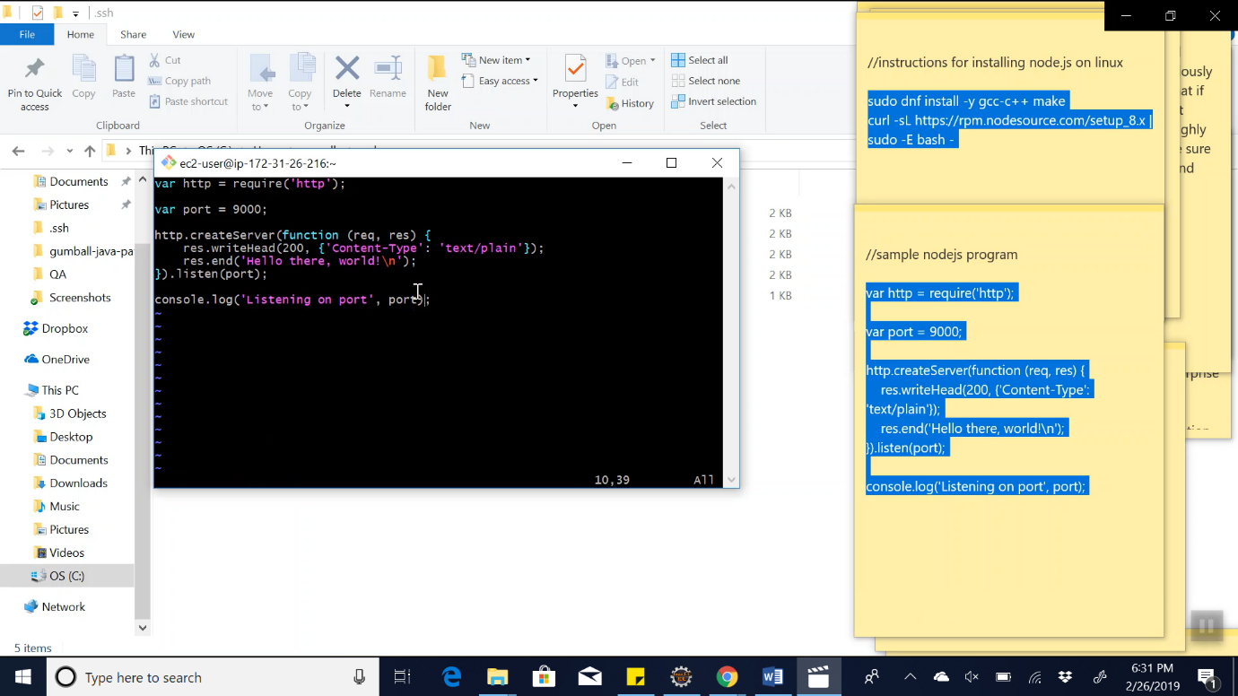

1. Then, to run the node file, run the following command:

node app.js

We see the following in console : “Listening on port 9000”

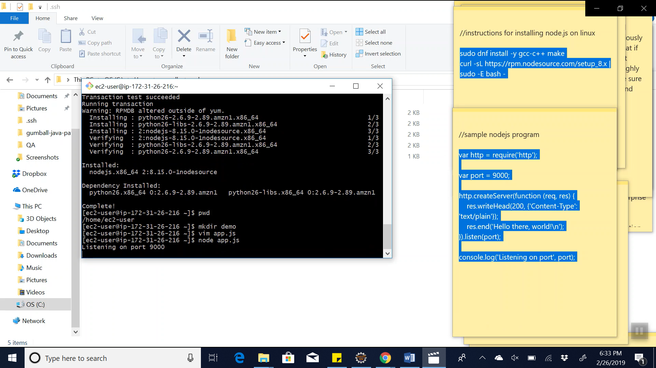

1. Run the application through the public DNS

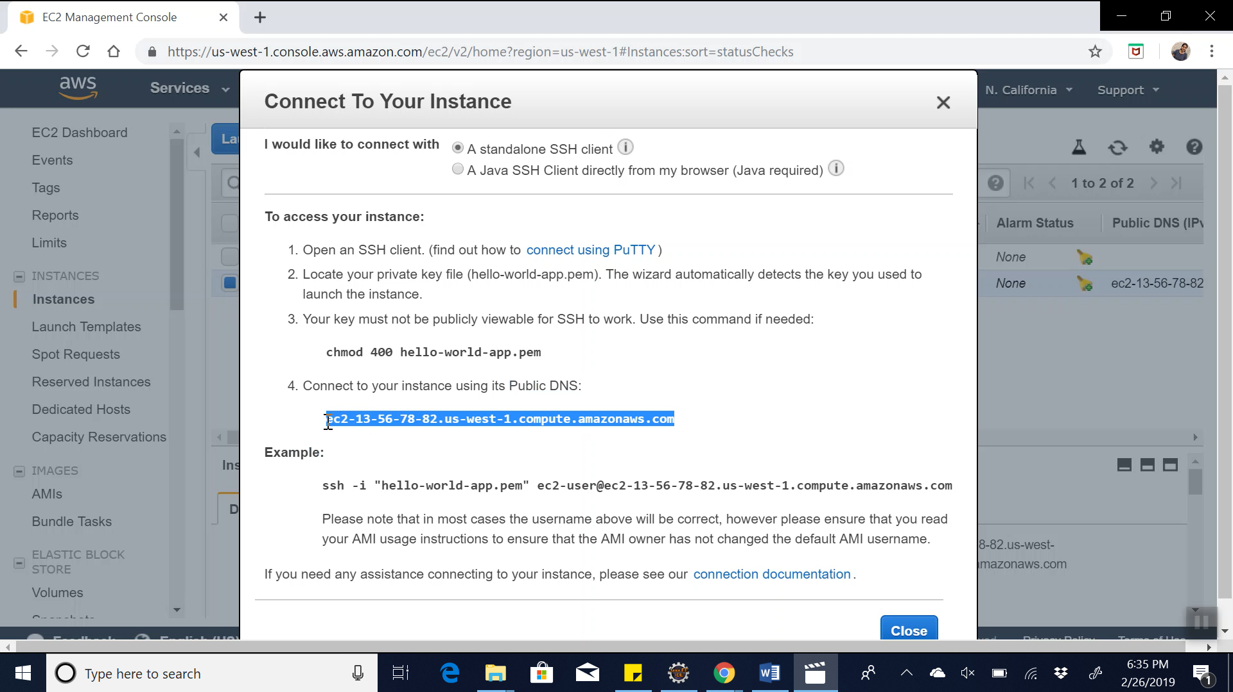

1. Then add port number at the end :9000

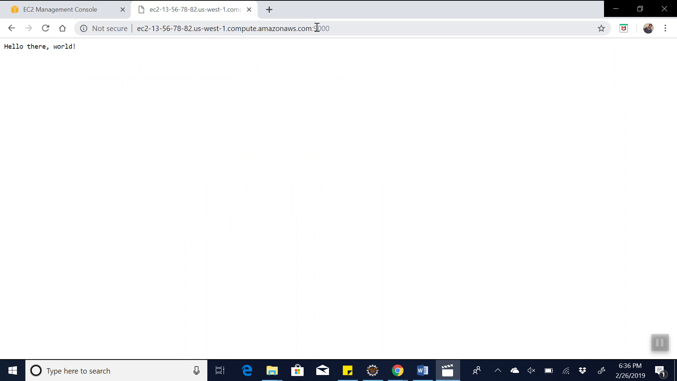

1. Thus we can see that the nodejs application is up and running in the public DNS

**4.Amazon Cloudwatch feature and report:**

1. To view the cloudwatch report :

<https://us-west-1.console.aws.amazon.com/cloudwatch/home?region=us-west-1#>

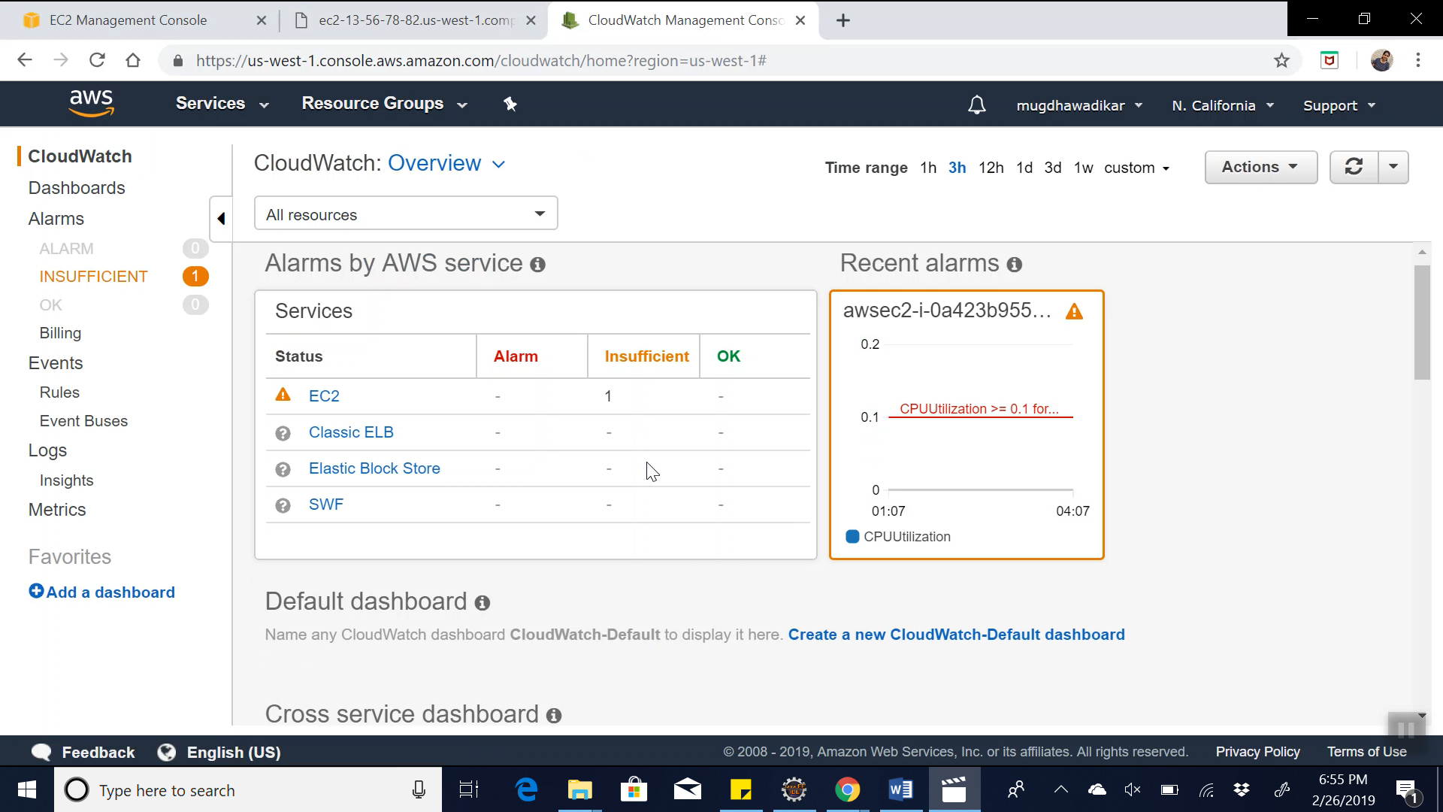

2. As we can see, there are two instances available in cloudwatch . To check the name of the instance, check the running instance in AWS console. Here , as we can see, the instance which we have just launched is : i-0a0333f297635326d. So we need to track this instance’s utilization in cloudwatch.

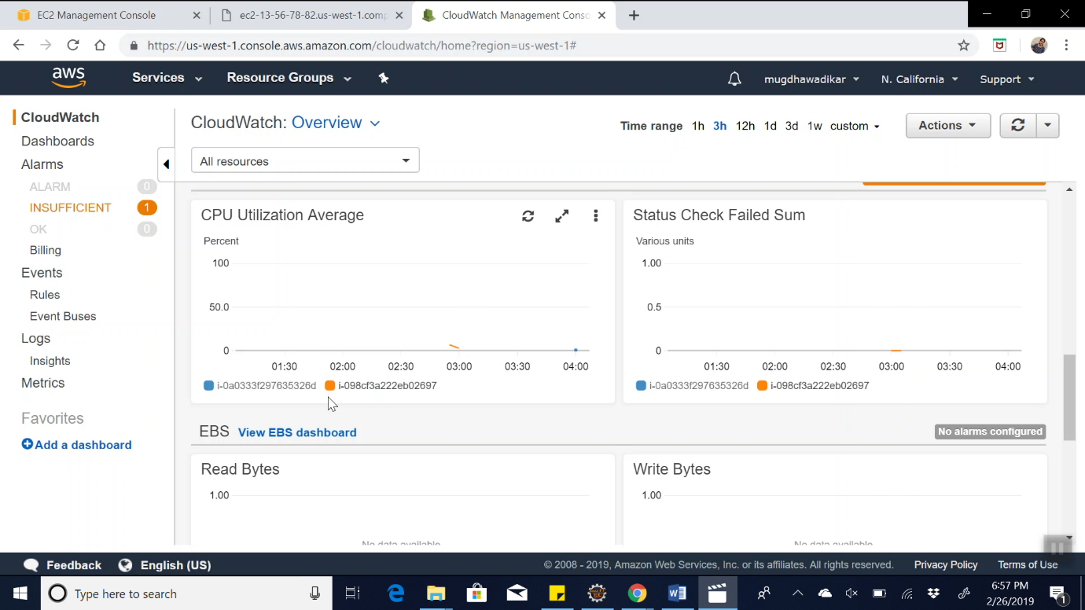

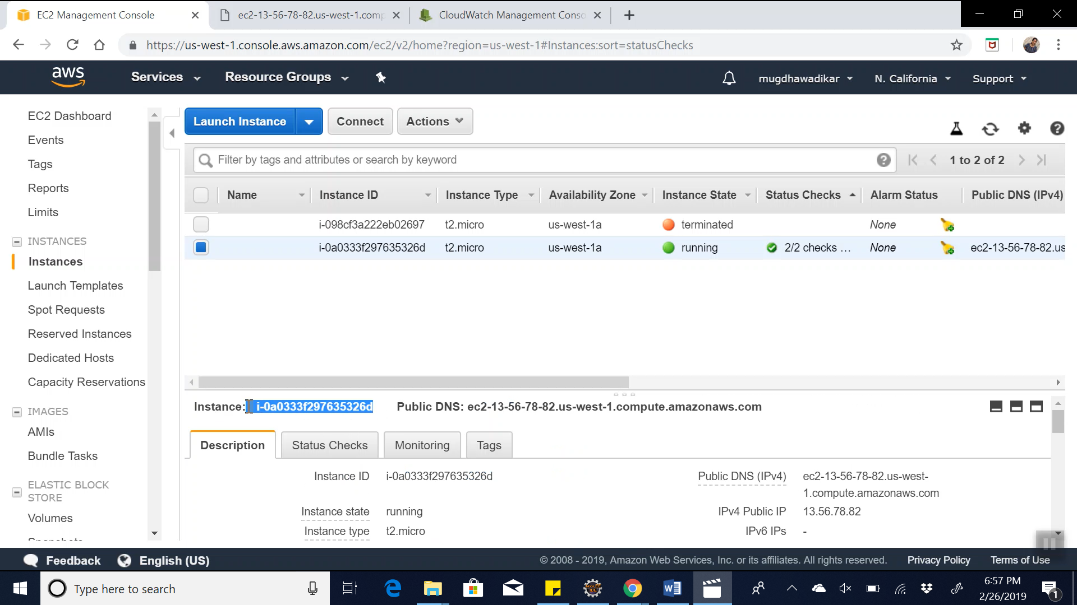

3. Unselect the other instance so that we can concentrate on the running instance which we created in earlier steps. So right now we can see the details of the instance which we have created in the earlier steps.

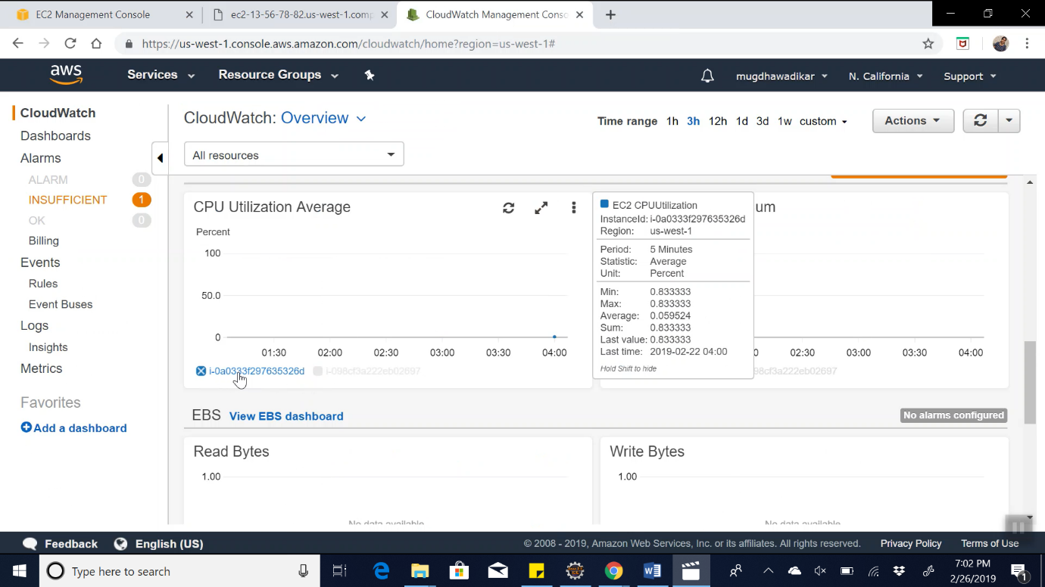

4. Zoom into the CPU Utilization graph :

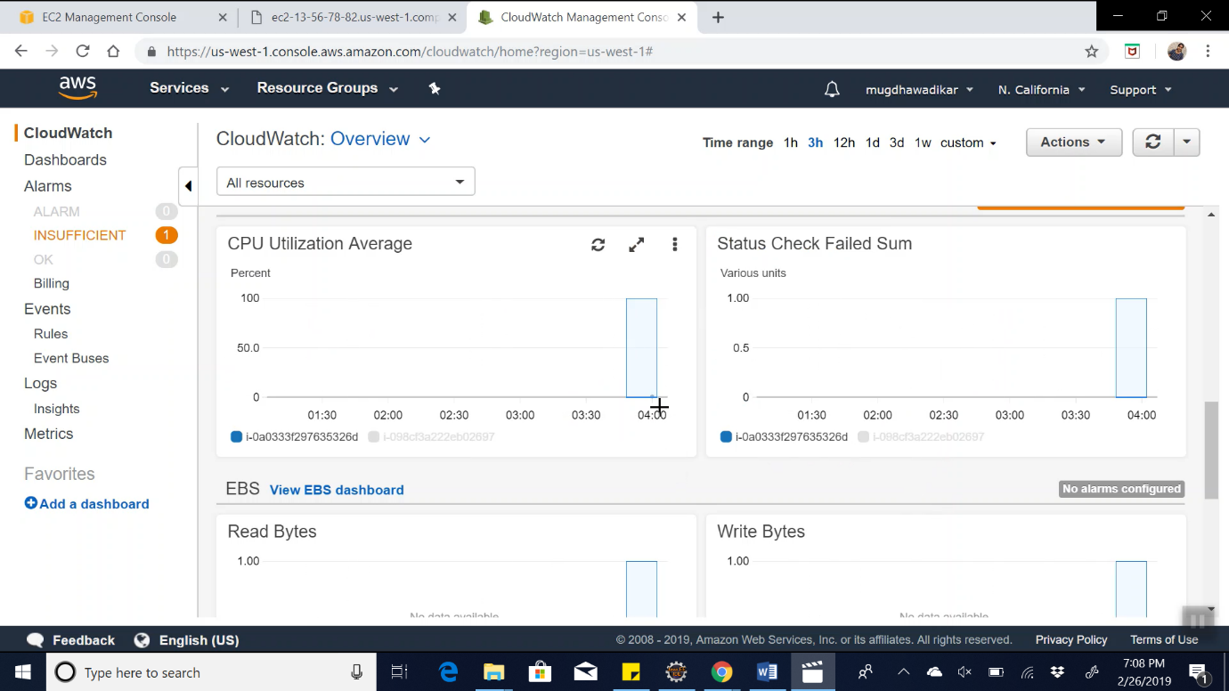

5. We can see the details of the instance in the following clip:

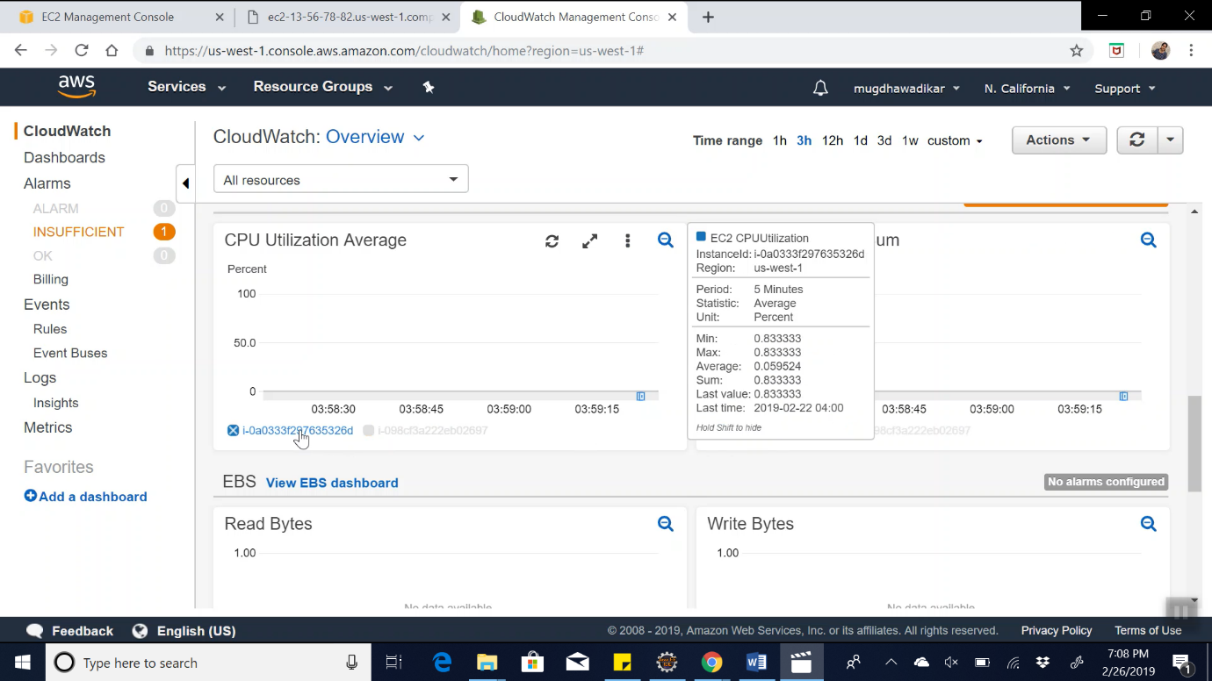

6. View the instance in Cloudwatch Metrics :

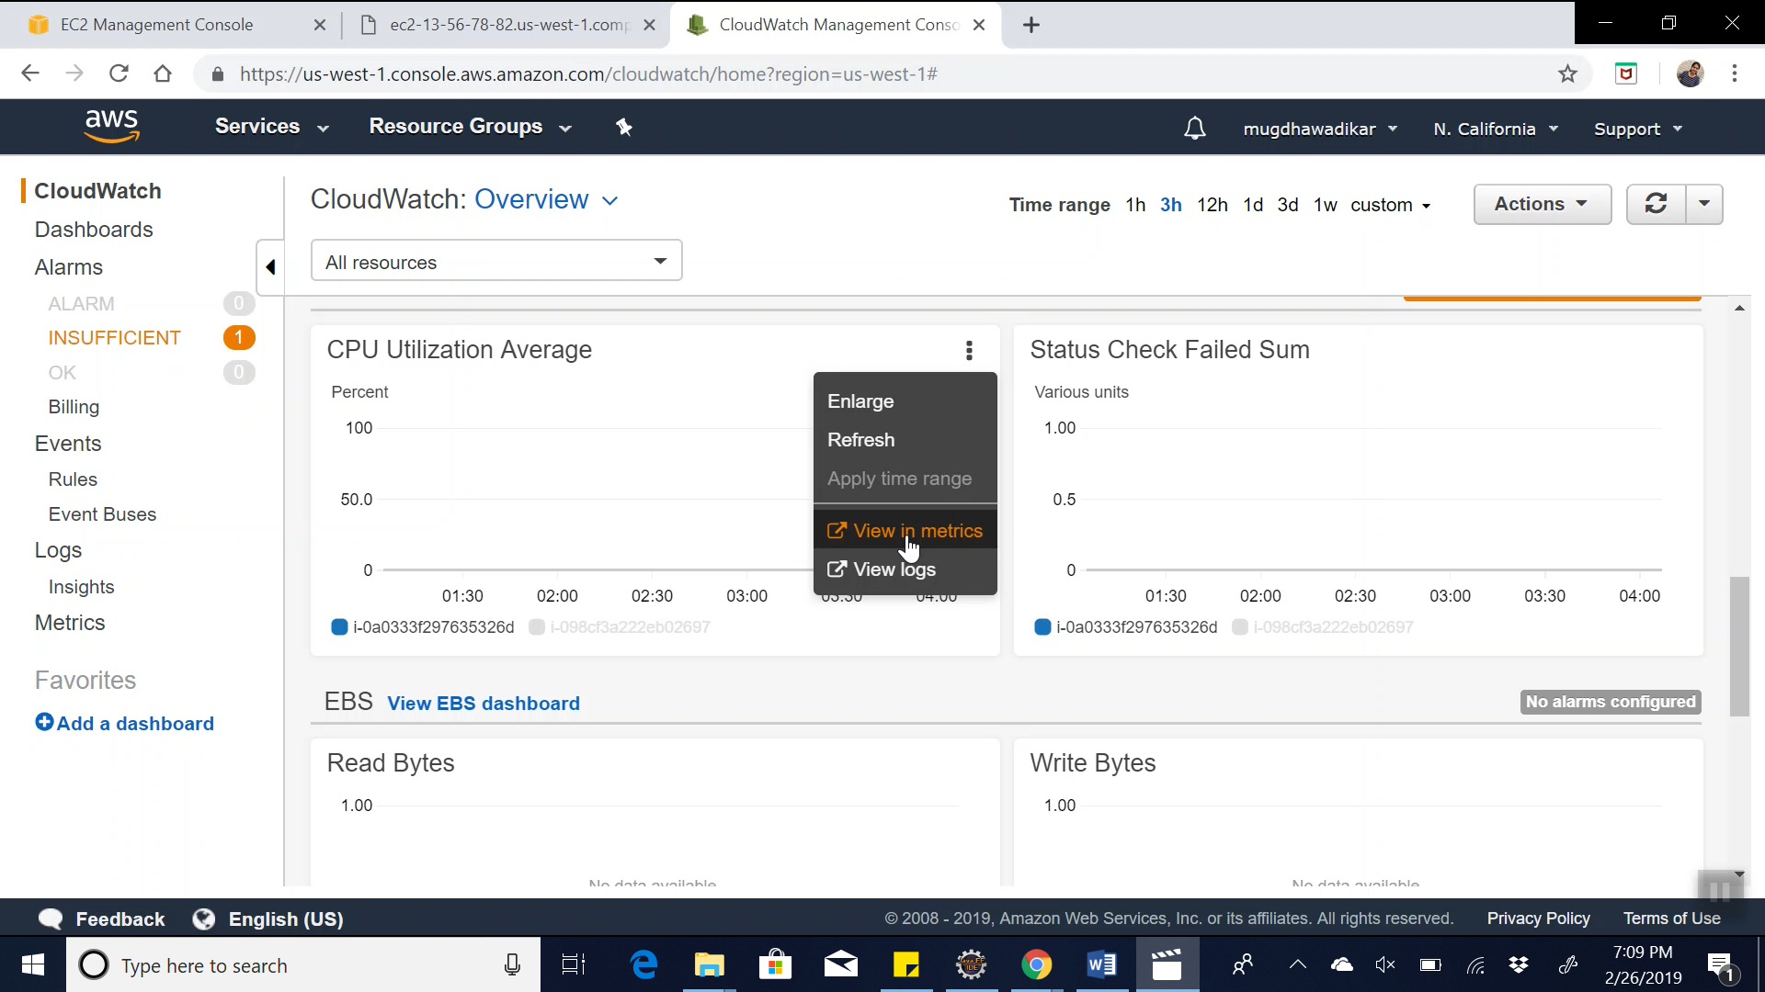

7. We can see the utilization in timeframes such as 1 h, 3h, 12h, etc…

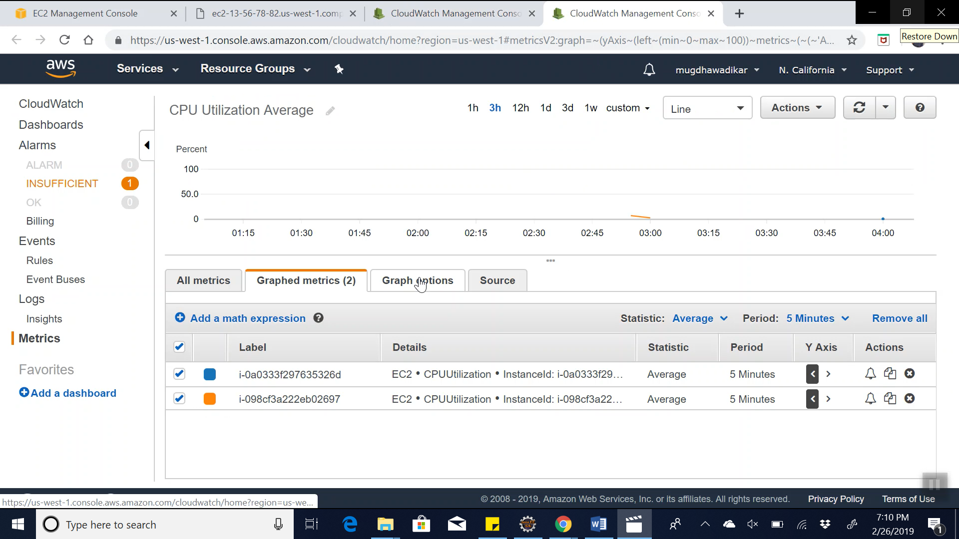

**Summary**:

* Set up an AMAZON WEB SERVICE (AWS) user account
* Create an EC2 instance
* Launch and deploy the selected application (or an instance) onto selected cloud environment. In my case I selected an EC2 Linux environment and created a sample node.js application that showed “Hello There, World” if we access the public domain address.
* Watch / Monitor the instance in Amazon Cloudwatch.